How to Install

* Take the conten of \codeChallenge\bitsochallenge\builder\build directory and put it on your WebServer
* It too works into Web Server For Chrome app
* In Web Server for Chrome you need to select the build directory and press start server

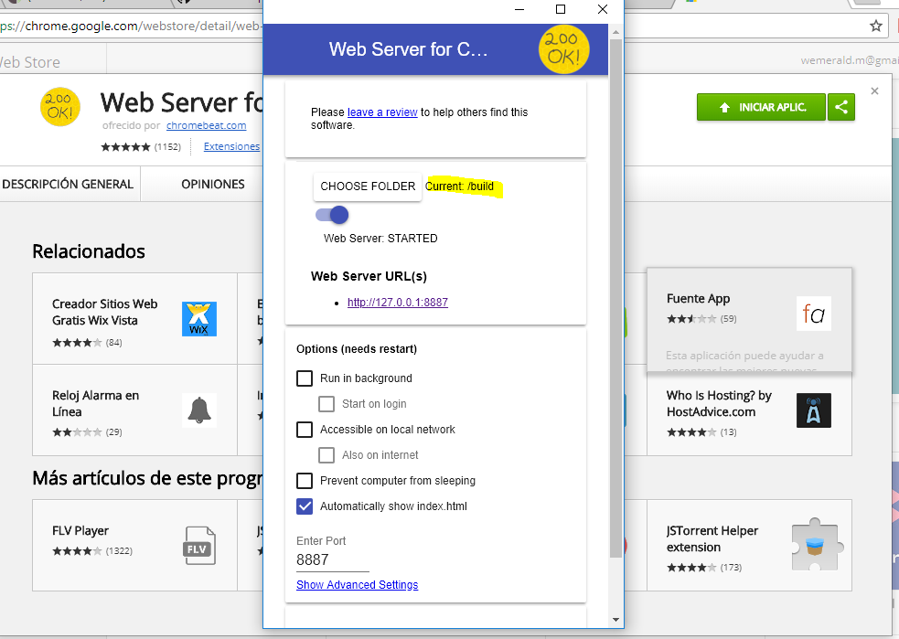

Click the link below Web Server URL and enjoy.

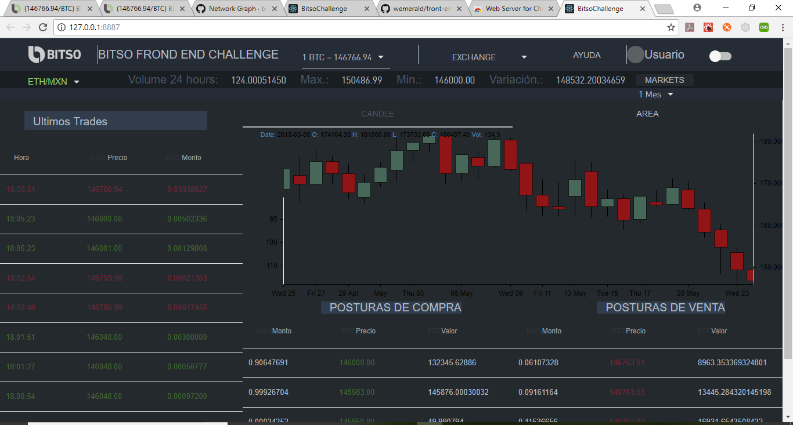

Component Testing

Main Bar

* Toggle Theme between dark and White Coponents affected:
* Labels in Headers and Tables
* Backgound in tables
* Labels in Dropdowns Menus

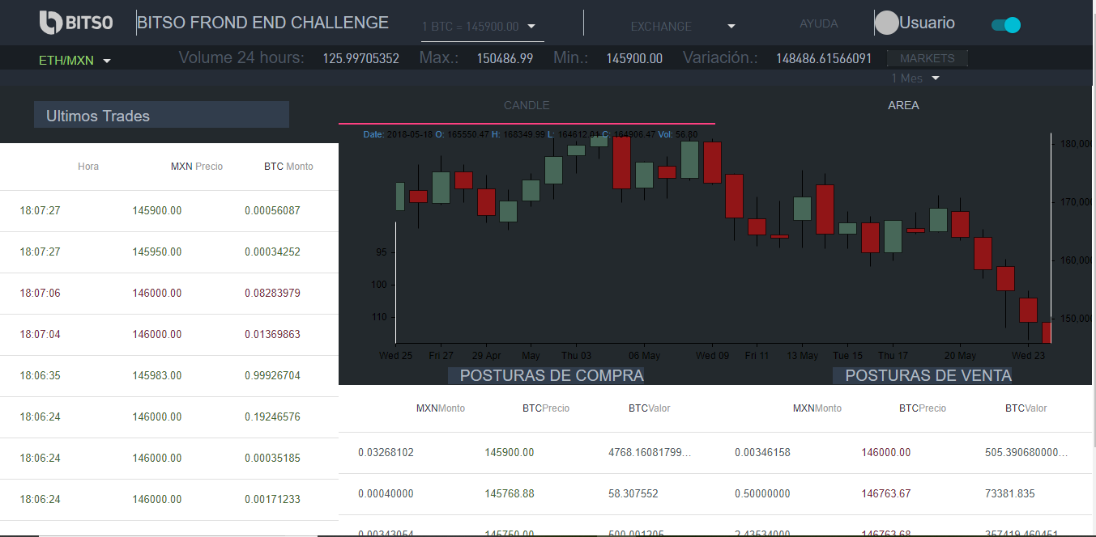

* Currency Bar / DarkBar secondary
* On change updates the volume, variation, Max and Min about current coin



* Markets panel (button Market)
* On click a left sidebar appears (actual markets no implemented).



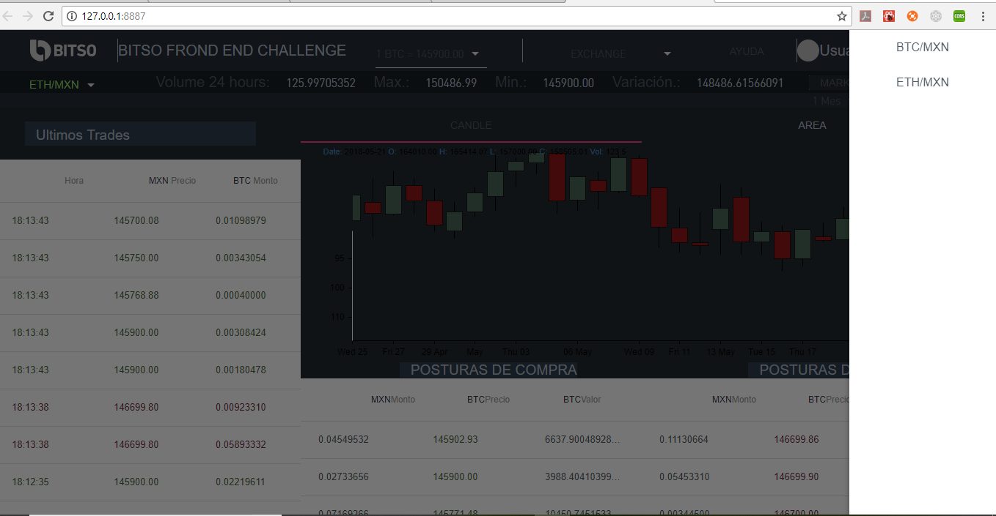

* Last trades Component
* Actually just return information for btc_mxn, but it could be customizable by parameter with a less work cost.
* This component is refreshing every 5 seconds to obtain the las information.

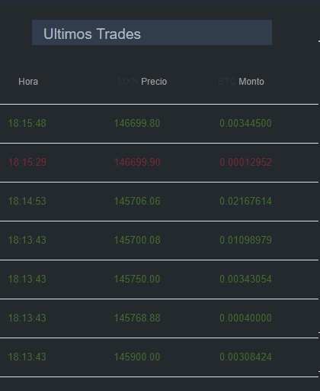

* Buy and Sell Activity
* This section is refreshing every custom time to show always the las activity
* Actually works for btc_mxn but could be parametrizable too.

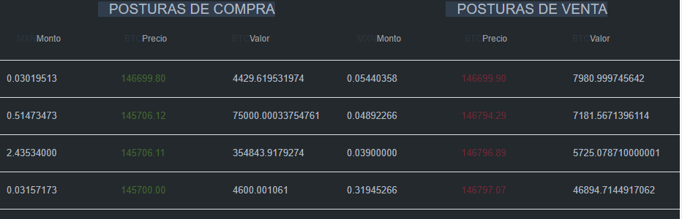

* Graphics/Charts
* A candle and Area Chart was implement in this solution, the charts template credits are of his creator (for more information visit <https://github.com/rrag/react-stockcharts>)
* The charts are embeded on two panels, you can choice what to show
* The chart period could be selected by the selector over chart

